 |  | A/HRC/46/55
 | Advance Unedited Version |  | Distr.: General  2 March 2021  Original: English
Human Rights Council
Forty-sixth session
22 February–19 March 2021
Agenda item 4
Human rights situations that require the Council’s attention
Report of the Independent International Commission of Inquiry on the Syrian Arab Republic*, ****
Summary
In its resolutions 44/21 and 45/21, the Human Rights Council requested the Commission of Inquiry to prepare a report on arbitrary imprisonment and detention in the Syrian Arab Republic, and to reflect on the trends over 10 years of the conflict. The present report summarises key trends related to imprisonment and detention in Syria from March 2011 to December 2020, including in relation to enforced disappearance and incommunicado detention, torture, inhuman or degrading treatment, sexual violence and death in detention. The scope of this mandate entailed massive investigations and the gathering of a wealth of testimonies and material that the Commission aims to give justice to in greater detail in future reporting.
I. Introduction
1. Over the past decade, no warring party in Syria has respected the rights of detained persons in line with international legal obligations. The use of arbitrary detention, torture and ill-treatment, including through sexual violence, involuntary or enforced disappearance and summary executions have been hallmarks of this conflict.
2. The violations and abuses have been carried out with such consistency, particularly by the Government, and have been reported so widely by the Commission and others that there can be no room to say they were being committed without the knowledge of the relevant chains of command. In the case of the Government of Syria, the data reflecting the transfer of detainees from other governorates to the capital, reflects a high degree of centralized control, in addition to other evidence showing a detailed bureaucracy with records of who is detained and where they are held.
3. The detention-related violations detailed in this report have been used by the parties to intimidate and punish. Whether through the taking of hostages for monetary gain, bribery or the payment of intermediaries for information on a family member’s fate, detention in Syria also became an extortion racket.
4. Parties to the conflict, with very few exceptions, have failed to investigate their own forces. Attempts to subject perceived or actual opponents to some form of criminal justice have consistently resulted in violations and abuses of the rights of those alleged perpetrators, and in many cases, the commission of international crimes. Meanwhile, States with influence on the conduct of the parties have clearly not done enough to change abusive behavior by those parties on the ground, and in some cases appear complicit in abuses.
II. A decade of detention and related violations
“The boy was lying on the floor and was completely blue. He was bleeding profusely from his ear, eyes and nose. He was shouting and calling for his mother and father for help. He fainted after being hit with a rifle butt on the head.”
A witness, himself a victim of torture, describing 14 year old Thamir Al Sharee on 3 May 2011
5. Arbitrary detention and related violations have been among the root causes, triggers and persistent features of the conflict that emerged in Syria ten years ago. Long-standing arbitrary detention of dissidents and activists were among the main grievances in Syria that inspired protests in early 2011, during which the population called for the release of political prisoners. Heavy-handed initial responses by the Government to those protests, from mass arrests of demonstrators to torture and numerous deaths in detention – including of children such as Thamir al-Sharee and Hamza Ali al-Khateeb – contributed to the rapid spiral into an armed conflict as of February 2012. That year, armed groups, and later United Nations designated terrorist groups, gained influence over increasing numbers of Syrian population centres, initiating the ebb and flow of territorial control that would continue between belligerent parties in ensuing years, as described in the Commission’s recent report (A/HRC/46/54).
6. Most prominent among these groups have been the former Free Syrian Army (FSA)-affiliated groups and factions prior to their consolidation under other umbrellas and other groups such as Jaysh al-Islam and Ahrar al-Sham; UN terrorist-designated Hayat Tahrir al Sham (HTS, previously Jabhat al-Nusra) and the Islamic State in Iraq and the Levant (ISIL); Turkish-supported “Syrian National Army” (SNA); as well as Kurdish-led forces, including the Kurdish People’s Protection Units (YPG and YPJ) that, as of 2015, operated under the US-supported “Syrian Democratic Forces” (SDF).
7. Over time, armed groups and terrorist organizations adopted detention-related practices in the areas under their control that were strikingly similar to those of Government and pro-government forces. Enforced disappearance and incommunicado detention, torture, inhuman or degrading treatment, sexual violence and death in detention were documented in detention facilities operated by all parties across the country (see maps in Annex II). These ranged from makeshift places of detention in basements, schools, military bases or at checkpoints, to purpose-built prisons (operated by different warring parties as territorial-control shifted) or heavily guarded displacement camps. The lack of basic habeas corpus across Syria facilitated the multitude of violations many individuals suffered in detention by all duty bearers.
III. Overview of the prevalence of detention-related violations since 2011
8. Pursuant to its established methodology, which is based on standard practices of commissions of inquiry and human rights investigations, the Commission relied primarily on 7,874 interviews conducted from 2011 to 2020 in the preparation of this report. To supplement the information collected in relevant interviews, official documents, reports, photographs, videos and satellite imagery were analysed from multiple sources, including following the Commission’s call for submissions. The standard of proof was considered met when there were reasonable grounds to believe that incidents had occurred as described, and, where possible, that violations had been committed by the warring party identified.
9. In view of the mandate to cover nearly a decade of detention in the Syrian Arab Republic, a quantitative analysis was undertaken of the Commission’s own 2,658 interviews related to arbitrary detention by forces belonging to six main groups of parties to the conflict noted in the previous section.
10. While the resulting data provides a basic overview of trends over the entirety of the conflict, it is subject to a number of important caveats (see Annex III). Specifically, the Commission’s interviews were conducted over almost a decade without a view to undertaking such quantitative statistical analysis and the sample collected was subject to the investigative priorities of the respective investigation period. Moreover, safe access to victims and witnesses of detention related violations became increasingly difficult in recent years due to protection concerns, often related to their dwindling possibilities to flee the country. The presented statistics can therefore not provide a comprehensive analysis of detention related violations that have taken place in the conflict.
11. In this dataset, 85 per cent of identified victims of violations in detention were adults and 6 per cent were children; 73 per cent were male and 20 per cent of victims were female; 73 per cent were from majority religions, ethnicities or sects, which broadly matches UN demographic estimates, while 21 percent were from minority groups - with the remaining percentages undetermined. Victims came from all governorates, see the below map.
Map of origin of victims documented in interviews
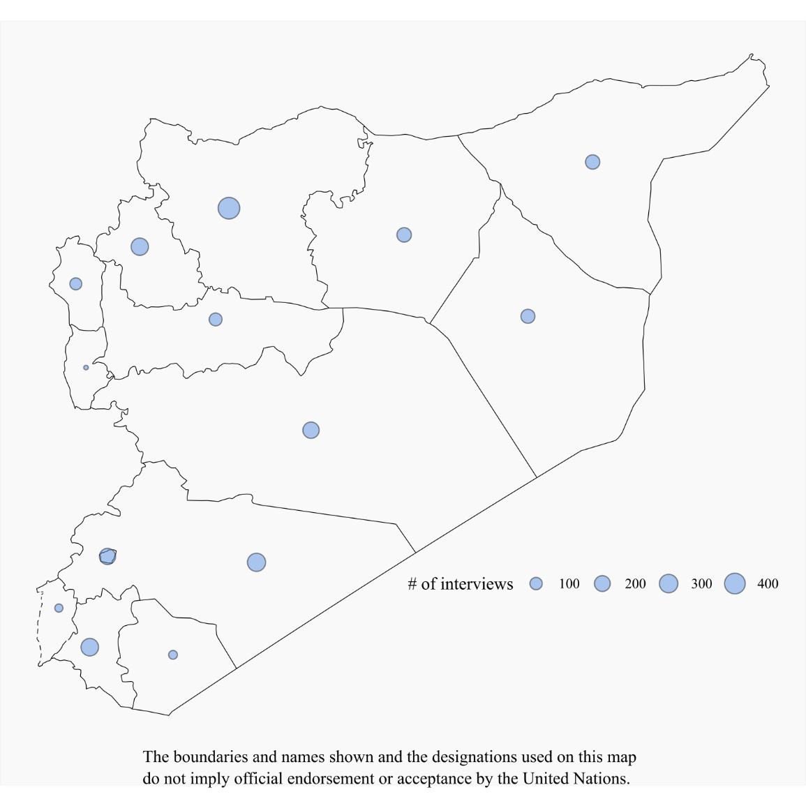
12. The below table indicates the number of interviews conducted on arbitrary detention concerning each of the six main parties to the conflict, and the number of additional detention-related violations identified per interview (of the five foremost violations, namely enforced disappearance and incommunicado detention, torture, inhuman or degrading treatment, sexual violence and deaths in detention).
Data on detention based on 2,658 interviews 2011-2020
Duty bearers | Number of relevant interviews on arbitrary detention | Overall percentage of interviews (rounded) | Number of additional detention-related violations identified | Average number of additional detention-related
Government of Syria and pro-Government forces (GOS) | 1577 | 59% | 3210 | 2.04
ISIL | 409 | 15% | 927 | 2.27
HTS | 211 | 8% | 405 | 1.92
SDF and related entities | 198 | 7% | 234 | 1.18
FSA and other armed groups | 177 | 7% | 286 | 1.62
SNA | 86 | 3% | 144 | 1.67
Total | 2,658 | 100 | 5,206 | 1.96
13. The following four graphs and tables indicate the yearly percentages (2011-2020) based on analysis of the 2,658 testimonies, concerning the six main duty bearers and the five foremost detention-related violations. The percentages shown only provide a basic indication of trends since they were calculated on the basis of the number of testimonies, not the number of documented violations. By way of example, one testimony concerning deaths in detention may contain corroborated information of the deaths of several named and identified detainees, however in the dataset and related statistics this is reflected as just “one” (one testimony/interview or one violation).

Overall data on detention based on 2,658 interviews conducted from 2011-2020
Custody-related violation | Duty bearers | Number of interviewees who experienced the violation when held | Percentage of interviewees who experienced the violation in the relevant duty bearer data set | Number of interviewees who witnessed/reported the violation (suffered by others) | Percentage of interviewees who witnessed/reported the violation in the relevant duty bearer dataset
Enforced disappearance/  incommunicado  detention | Government of Syria and pro-Government forces (GOS) | 409 | 26% | 861 | 55%
Enforced disappearance/  incommunicado  detention | ISIL | 81 | 20% | 218 | 53%
Enforced disappearance/  incommunicado  detention | HTS | 64 | 30% | 77 | 36%
Enforced disappearance/  incommunicado  detention | SDF and related entities | 31 | 16% | 55 | 28%
Enforced disappearance/  incommunicado  detention | FSA and other armed groups | 38 | 21% | 76 | 43%
Enforced disappearance/  incommunicado  detention | SNA | 17 | 20% | 33 | 38%
Torture | Government of Syria and pro-Government forces (GOS) | 474 | 30% | 595 | 38%
Torture | ISIL | 82 | 20% | 177 | 43%
Torture | HTS | 44 | 21% | 65 | 31%
Torture | SDF and related entities | 20 | 10% | 27 | 14%
Torture | FSA and other armed groups | 34 | 19% | 36 | 20%
Torture | SNA | 16 | 19% | 29 | 34%
Inhuman and/or degrading treatment | Government of Syria and pro-Government forces (GOS) | 463 | 29% | 575 | 36%
Inhuman and/or degrading treatment | ISIL | 93 | 23% | 166 | 41%
Inhuman and/or degrading treatment | HTS | 69 | 33% | 88 | 42%
Inhuman and/or degrading treatment | SDF and related entities | 57 | 29% | 69 | 35%
Inhuman and/or degrading treatment | FSA and other armed groups | 45 | 25% | 39 | 22%
Inhuman and/or degrading treatment | SNA | 21 | 24% | 33 | 38%
Rape and other forms of sexual violence | Government of Syria and pro-Government forces (GOS) | 91 | 6% | 211 | 13%
Rape and other forms of sexual violence | ISIL | 28 | 7% | 51 | 12%
Rape and other forms of sexual violence | HTS | 6 | 3% | 4 | 2%
Rape and other forms of sexual violence | SDF and related entities | 2 | 1% | 5 | 3%
Rape and other forms of sexual violence | FSA and other armed groups | 4 | 2% | 4 | 2%
Rape and other forms of sexual violence | SNA | 3 | 3% | 10 | 12%
Deaths in detention
Duty bearers | Via reports or through witnesses | Saw the body or death in detention | With death certificate | Received body and with death certificate
Government of Syria and pro-Government forces (GOS) | 249 (15%) | 146 (9%) | 56 (4%) | 11 (1%)
ISIL | 113 (28%) | 118 (29%) | N/A | N/A
HTS | 50 (24%) | 23 (11%) | N/A | N/A
SDF and related entities | 13 (7%) | 0 | N/A | 1 (.5%)
FSA and other armed groups | 38 (21%) | 11 (6%) | N/A | N/A
SNA | 5 (6%) | 0 | N/A | N/A
III. Government of Syria and pro-Government forces
“Everybody was given a Kalashnikov…. We were told: ‘You are going to demonstrations. You might get orders to shoot and if you do, shoot.’ [….] Most demonstrators dispersed, but two to three thousand remained. An official gave orders to shoot at them. About 10 were killed, 23 injured. We arrested some of them, between 10 and 20. Those we arrested were mostly people trying to help the injured. The injured were held together in a courtyard where officers started beating them without mercy.”
Security official deployed at a demonstration in Damascus in April 2011
14. For the Government of Syria and pro-Government forces, data showed that arbitrary detention and related violations were committed on a massive scale during the first years of the conflict.
15. Starting in Dar’a, and then expanding across the country, the Government carried out mass arrests during demonstrations and military operations, followed by arbitrary detention at checkpoints and borders. Government forces targeted various groups, particularly in restive areas, including human rights defenders, health and rescue workers, relatives of wanted individuals and military aged men. A vast network of detention centres (Annex II) was used and individuals were subjected to numerous violations such as torture, inhuman and degrading treatment and sexual violence, and held incommunicado. Tens of thousands of men, women, boys and girls who were taken into Government custody remain forcibly disappeared at the time of writing, ten years after the first waves of mass arrests. 91 per cent of the victims of violations identified in interviews were from majority religions, sects or ethnicities, while 4 per cent were from minorities – possibly indicating that restive areas inhabited predominantly by Sunni Muslims may have been targeted, as previously reported.

16. Habeas corpus was disregarded in almost all instances. Of the over 500 former detainees interviewed, almost none had been afforded the opportunity to present their case before the judiciary within a reasonable time. Those arrested were typically not given any information regarding the reason for their arrest, nor, if informed of the charges, presented with evidence supporting the allegations. Detainees were routinely tortured to extract confessions, or forced to sign or fingerprint pre-written declarations that they had not been allowed to read. Those detainees who were eventually referred to parts of the court system on criminal charges were invariably subjected to multiple violations of the right to a fair trial. Proceedings of the Counter-Terrorism Court and Field Military Courts were of particular concern due to the general lack of evidence utilized and the imposition of death sentences. Eyewitness accounts from Counter-Terrorism Court proceedings indicate that hearings are brief, with scant, if any, evidence presented in support of serious charges. Regarding field courts, court sessions would last only minutes, with no witnesses or lawyer present. Some defendants were only informed of the verdict years after their trial. Others learned that they had been sentenced without ever being present at a hearing.
17. As Government forces recaptured territory in more recent years, thousands of civilians fleeing besieged areas, such as eastern Aleppo Governorate and eastern Ghutah in Rif Damascus, were subject to internment in so-called “IDP” shelters. Continuing arbitrary detention has also been documented in recaptured areas following truces or “reconciliation” agreements.
“They tortured me…, then the interrogator told me ‘We can kill you here and now, nobody will ever know’.”
A former prisoner of the Government’s security forces in Homs
18. Widespread enforced disappearance has been deliberately perpetrated by Government security forces throughout the decade on a massive scale, to spread fear, stifle dissent and as a punishment. The first few years of the uprisings witnessed the highest rates of disappearances. In a strikingly consistent pattern, arrests were mostly carried out without a legal warrant and security forces did not inform arrestees, nor their families, where they would be taken. Since 2011, 63 per cent of testimonies related to detention by the Government provided information on incidents of enforced disappearance. The whereabouts of tens of thousands of those arrested throughout the conflict was unknown at the time of writing.
19. Individuals who were released from detention often either payed a bribe, served their sentence, were subject to “amnesties”, or were released pursuant to a combination of the aforementioned. For example, one man, arrested in 2011 and transferred to Sednaya Miltiary Prison, only learned of the verdict rendered against him four months after it was issued by the field court when he was transferred to a prison in Suwayda’ governorate. After spending nine years in prison, he was released in 2020 as part of a presidential amnesty but only after paying a bribe. Many others were not informed of the reason for their release.
20. Men, women, boys and girls in detention were subjected to inhuman treatment and torture, including rape and other forms of sexual violence. 474 interviewees were direct victims of torture and 463 of inhuman treatment, and 1,170 individuals waterwitnessed or had credible reports of such violations. At least 20 different horrific methods of torture used by the Government of Syria have been extensively documented. These include administering electric shocks, the burning of body parts, pulling off nails and teeth, mock executions, folding detainees into a car tyre (Dulab) and crucifying or suspending individuals from one or two limbs for prolonged periods (Shabeh), often in combination with severe beating with various tools such as sticks or cables. Torture methods were both physical and mental and had severe long-term consequences for detainees or frequently led to their death. Inhuman conditions documented across Government detention centres often in and of themselves amounted to torture.
“When I regained consciousness I was in my cell and incontinent and bleeding heavily from my vagina and anus. But the most painful part of the incident was the emotional pain.”
Young woman, victim of abuse of Government security officials
21. Although sexual violence is significantly underreported due to a variety of reasons, 91 survivors of sexual violence have been interviewed and a further 211 individuals either witnessed or gave information regarding credible reports of sexual violence in Government forces’ detention. Rape and other forms of sexual violence, including sexual assault and sexual humiliation, were used against women, girls, men and boys, including those as young as 11 years, to extract information, as a punishment, or to humiliate them and their families.
22. In hundreds of documented cases, violations resulted in death in detention, including children and the elderly. Former detainees detailed how cellmates were beaten to death during interrogations and in their cells, or died due to severe injuries caused by torture or ill-treatment. Others perished because of inhuman living conditions inflicted on the prison population, including severe overcrowding, lack of food and unclean drinking water. Prisoners were given inadequate or no medical care, and died from preventable conditions such as diarrhoea or other contagious infections that spread in the unhygienic and overcrowded cells. Information provided to family members on deaths was typically extremely limited, and often provided only after bribes or extortion by State authorities, including civil registries, military hospitals and military police. In total, the Commission gathered 462 testimonies on death in Government detention. Thirty-two per cent of interviewees saw bodies or directly witnessed death in detention, 12 per cent were provided with a death certificate and 2 per cent received the body and a death certificate – while 54 percent of this information was received through reports or via witnesses.
23. The exact number of detainees who have died in detention is unknown. Conservative estimates indicate that tens of thousands of individuals were killed while in custody of Government agencies since 2011. Such estimates are supported by accounts obtained from multiple defectors from the security apparatus. Multiple sources indicates that, following the registration of deceased detainees at military hospitals, the bodies were transported and buried in various mass graves.
24. Two specific mass burial sites in Najha and Qutayfa on the outskirts of Damascus have been identified using information from defectors, satellite imagery collected over the past decade and family members of deceased. Bodies were transported from Tishreen, Harasta and 601 Mezze Military hospitals in Damascus and included detainees who had died in the custody of the four main intelligence agencies, as well as those who died in custody or were executed at Sednaya Military Prison following convictions by the military field courts. Although it cannot be excluded that other burials could have led to the earth disturbance observed on multi-year satellite imagery in both locations, there are reasonable grounds to believe that detainees who died or were extrajudicial killed while in State custody are buried at these locations. Other locations used as mass graves for detainees, as well as other means of disposing of bodies of those killed in detention, including the alleged used of incinerators, remain under investigation.
25. All parts of the Syrian security forces have been involved in the above outlined violations since 2011. Former officers of the Syrian intelligence apparatus have described how torture and ill-treatment against detainees was systematic throughout the security apparatus and involved high-ranking officers. Any arrest, detention or release of detainees in a given security branch required the approval of the head of each directorate. Likewise, all deaths of detainees were reported to the head of agency.
26. Moreover, data clearly showed how individuals were moved to Damascus in a centralised manner. The network graph below shows that many victims were transferred to or ended up in facilities in Damascus.
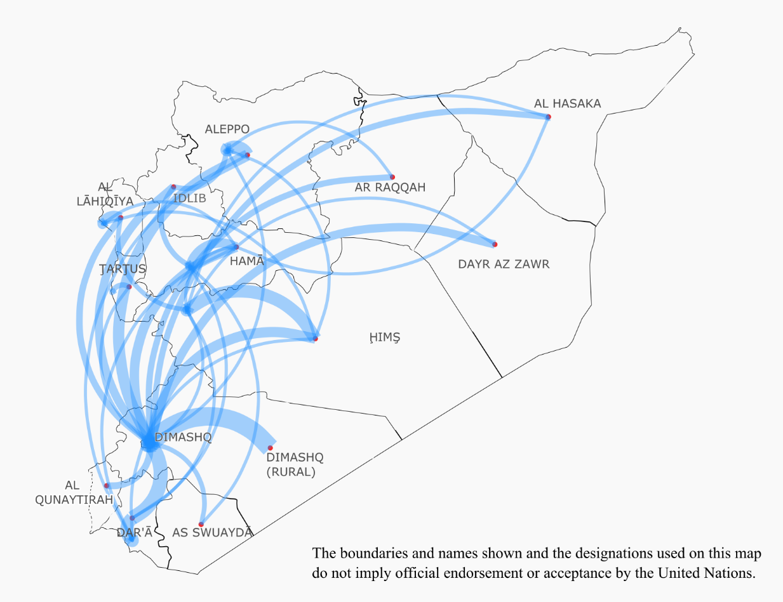
27. Government forces kept meticulous registers of detainees, as international standards prescribe, but failed to inform families of the fate of detainees, as also required by international law. Tens of thousands of families have desperately awaited news for nearly a decade.
IV. Non-State (anti-government) armed groups
28. Anti-Government armed groups began unlawfully depriving individuals of their liberty as early as 2011 without any semblance of due process, including journalists, human rights activists, perceived political opponents and other civilians, such as relatives of Government soldiers or members of religious minorities. Individuals were often taken hostage for the purpose of being used in negotiations for the release of captured fighters from their own faction. Captives and detainees were treated abominably, held in inhumane conditions or subjected to torture or cruel and degrading treatment.
A. Free Syrian Army and other armed groups
“The FSA has captured soldiers from the Syrian army, many, too many…They are brought to trial, to the Imam, and if the person is found guilty, we call his parents so he can say goodbye and then we kill him.”
FSA fighter on summary executions of captured soldiers in Jisr ash Shugur, Idlib
29. Early on in the conflict, most of the armed groups came together under the banner of the ‘Free Syrian Army’ (FSA), initially established by Syrian soldiers defecting from Government forces. Armed groups within the FSA varied in terms of capabilities, composition and tactics, which in turn impacted their detention-related practices. Detention related violations by the FSA and related anti-government armed groups, including Jaysh al-Islam and Ahrar al-Sham, have been documented from 2011 with levels remaining steady until 2018. In 2019, there was a decrease that may be due to a number of factors, including the emergence of the SNA as a coherent body in late 2017, as well as the general loss of territory by smaller armed groups.

30. Initially, FSA-affiliated armed groups and other anti-government armed groups engaged in hostage taking and kidnapping of captured Government soldiers, their family members, or foreign nationals, for ransom or exchange for Government-held detainees. In other instances, people belonging to ethnic or religious minorities were taken hostage for sectarian score settling, often due to perceived Government support. As the conflict evolved, FSA-affiliated groups received international support through military operations rooms in Turkey and Jordan, which increased their capacities to hold territory and develop their own police force and justice system.
31. Acts tantamount to enforced disappearances by these armed groups were documented from November 2013 onwards and targeted civilians perceived to be supportive of the Government, human rights activists or other individuals publicly expressing criticism of armed groups. One hundred and fourteen testimonies on enforced disappearance and incommunicado detention by the FSA and other related armed groups have been collected, one third from former detainees.
32. Persons deprived of their liberty were held in dire conditions, mistreated and tortured, with 89 interviews with victims of torture and or inhuman treatment being documented, and another 85 individuals who witnessed or credibly reported on such violations.
33. Incidents of sexual and gender-based violations perpetrated by armed groups have occurred since their emergence in late 2011 in Damascus and Aleppo and were primarily against women and girls for motives related to exploitation, sectarianism, or revenge. As noted above (see footnote 16), the eight documented testimonies of rape and other forms of sexual violence should not be regarded as indicative of the frequency of sexual violence in FSA detention.
34. Killing of detainees occurred primarily in context of the capture and detention of Government soldiers and fighters of rival groups. Dozens of cases of extrajudicial and summary executions of captured fighters by opposition armed groups have been documented, including pursuant to decisions of makeshift bodies purportedly following their own interpretation of sharia law. The Commission documented several accounts of captives being judged by military commanders, as well as community and religious leaders, indicating that these courts or mechanisms were not ‘regularly constituted courts’. The functioning of these makeshifts courts varied depending on the armed group controlling the area. Forty-nine interviews provided information on summary executions or other deaths of individuals held by the FSA and other armed groups.
B. Syrian National Army
“They punched me and beat me with cables. The interrogator told me ‘Yezidis are infidels. We will kick you out from our land. You will die in here’.”
Yazidi woman detained at the SNA Military Police Headquarters in Afrin in 2020
35. In August 2016, numerous factions previously affiliated with the FSA participated alongside Turkish armed forces in the cross-border Operation Euphrates Shield, gaining control over northern parts of Aleppo, including I’zaz areas. By the end of 2017, these armed groups unified under the banner of the Syrian National Army (SNA). Between 2018 and 2019, SNA participated in two additional operations alongside Turkish armed forces, namely Operation Olive Branch (2018) and Operation Peace Spring (2019). These operations gave rise to SNA forces ultimately gaining control over parts of Afrin district and east of the Euphrates River, including Ayn al-Arab, Tall Abyad and Ra’s al-Ayn areas (Hasakah).
36. The SNA operates in three legions with multiple brigades under one singular command. As hostilities ceased in the Euphrates Shield areas, Afrin region, and – later on in 2019 – in Ra’s al-Ayn area, the court system and a network of prisons and detention sites were consolidated into one joint structure under the “Syrian interim government”, with judges reportedly appointed by Turkey and paid in Turkish lira. In parallel, SNA brigades run makeshift detention facilities in smaller towns and villages under their control, including an unidentified number of undisclosed detention sites.
37. Documented violations in detention were highest in 2018 and 2019, with a majority committed by members of the SNA military police. Eighty-seven per cent of identified victims were from minority religions, sects of ethnicities.

38. With the capture of Afrin, officially declared in 2018, residents described new patterns of arrests, beatings, kidnappings, and, on occasion, disappearances. As hostilities ceased, a security vacuum emerged, enabling a permissive environment for fighters to engage in abduction, hostage-taking and extortion of civilians.
39. A similar pattern, albeit to a lesser extent, was also observed in the Ra’s al-Ayn region following Operation Peace Spring, mostly affecting returnees of Kurdish origin, including women.
40. When abducted, victims – primarily of Kurdish origin – were typically taken to the headquarters of the brigade after being initially held in smaller towns or villages. Victims of hostage taking often saw their property or livestock confiscated and threats, extortion and beatings persisted after their release. Several civilians were kidnapped multiple times by different brigades and, while some were released upon ransom payments, others went missing or their bodies were found days after their abduction. When families approached SNA fighters to ask about the whereabouts of their loved ones, they were often provided with no information, threatened or beaten themselves.
41. As the SNA gradually expanded control and its operations evolved, detention became widespread. Though hostage-taking for monetary reasons persisted, the SNA attempted to systematize its detention practices through its vast network of detention facilities in Afrin and Ra’s al-Ayn regions (see Annex II). As in the case of abductions and hostage-taking, SNA members detained civilians, primarily of Kurdish and Yazidi origin, along with systematic confiscation of the victim’s property, extortion and beatings, which ultimately coerced many to leave their homes. Victims were interrogated by SNA members, often regarding alleged links to the self-administration and, occasionally, by or in the presence of Turkish officers. In numerous instances, civilians who had fled the Operation Peace Spring hostilities were detained upon return. Many found their homes looted and were forced to pay money to SNA members in order to retrieve household items.
42. Victims of arbitrary detention were most often held in SNA Military Police (MP) headquarters, Afrin central prison and Hawar Kilis Prison in Afrin city, as well as Masara prison in I’zaz (Aleppo) and Senaii military prison in Ra's al-Ayn (Hasakah) (see Annex II).
43. Detainees described being subjected to frequent and severe beatings during interrogation, often to extract confessions regarding alleged links to the Kurdish administration. Torture was most often perpetrated by members of SNA military police, SNA civil police, SNA Division 21 (Sultan Murad Division), SNA Division 22 (al-Hamza Division), al-Shami front, the SNA Division 11, and Brigade 111 (Northern Brigade).
44. As SNA detention practices rapidly evolved, women were increasingly rendered vulnerable to abduction (some for the purposes of forced marriage), and detained at checkpoints or during home and village raids. While detained, Kurdish women and, on occasion, those belonging to the Yazidi minority were also raped and subjected to other forms of sexual violence, including degrading and humiliating acts, threats of rape, performance of “virginity tests”, or the dissemination of photographs or video material showing the female detainee being abused.
45. Accounts indicated that Turkish forces and officers were regularly present in SNA detention facilities, including in the Military Police headquarters and the prison in Hawar Kilis, locations where ill-treatment of detainees was rampant. Four former detainees reported Turkish officials being present during interrogation sessions when torture took place.
46. Information also indicated that Syrian nationals, including women, who were detained by the SNA in Afrin and Ra’s al-Ayn were subsequently transferred to Turkey. While some have been released or returned to SNA custody in Syria, most of the transferred detainees remain to date in detention facilities in Turkey.
C. Syrian Democratic Forces and related entities
“Nothing is going to change. You are going to stay here, and you are going to stay here until you die.”
Woman, Al Hawl camp, Hasakah
47. In terms of yearly incidents of arbitrary detention, concurrent with the SDF and related entities’ emergence as entities holding territory, documented cases steadily grew from 2013 to 2016. The largest number of detention related incidents were documented in 2017. Numbers remained at relatively high levels in 2018 and 2019.
48. Camps in the northeast of Syria were established in this period, holding approximately 90,000 individuals deprived of their liberty as at the end of 2020, most of whom were women and children. Their situation is, for the large part, not reflected within the Commission’s dataset, on which the below chart and data is based.

49. As members of the YPG, and later on the SDF, expanded territories under their control, patterns of detention carried out by its members occurred in different forms.
50. In attempting to assert its de facto authority, YPG forces arbitrarily detained and, on occasion tortured, activists, NGO workers, political opponents (such as members of the Kurdish National Council), and other individuals, who expressed opposing views. Thirty such cases were documented between 2013 and 2020.
51. Former detainees reported that they were denied access to a defence lawyer and were held incommunicado for long periods without being informed of any charges against them. Victims described being held in overcrowded cells, where many had to crouch, and being confined for days without being able to undertake activities outside of the cell. Thirty-one individual testimonies reported experiences of incommunicado detention or enforced disappearance, and there were 55 accounts of people who had witnessed or received credible accounts of such acts.
52. Twenty-nine percent of former detainees interviewed who were held by the SDF and related entities reported experiencing inhuman or degrading treatment, ten per cent reported experiencing torture, and one per cent reported incidents of sexual violence. Fourteen interviewees provided information on death in detention. Violations were reported in a number of different facilities, including a “black site” prison in al-Malkiya village (Hasakah), Ayed prison (Raqqah), al-Shadadi prison and al-Sinaa detention facility (Hasakah) (see Annex II).
53. SDF has played a pivotal role in the battles against ISIL since early 2014 - offering the group legitimacy among States allied against ISIL – and has detained thousands of suspected ISIL fighters and interned others, including family members, as part of this effort.
54. Following the battles in Raqqah and Dayr al-Zawr governorates between 2017 and 2019, men and boys, including foreigners, aged 12 and above with alleged links to ISIL, were taken to SDF-run detention facilities throughout eastern Syria. Since then, many Syrian nationals suspected of having links with the terrorist group have been sentenced by the self-administration’s “People’s Defence Court”. Others, including foreign fighters, have been kept in detention, in sub-standard conditions conducive to detainee abuse. Some foreign ISIL suspects have been repatriated or otherwise transferred outside Syria, including to stand trial in their home countries, or in Iraq where some were reportedly sentenced to death. However, the vast majority remain in detention or internment, without current prospects for being tried locally, since the self-administration has announced their preference for countries of origin to repatriate these individuals and subject them to their respective jurisdictions, or for an ad-hoc international court to be established for this purpose. Some 110 boys with alleged links to ISIL were, as at mid-2020, held in a juvenile rehabilitation centre, while others were held together with adults at certain periods in other detention facilities.
55. Suspected former ISIL fighters’ spouses and children, many of whom are foreigners, were taken to displacement camps in areas under SDF control. Though some of those camps are now closed, others such as al-Hawl and al-Roj remain functioning, with encamped residents enduring inadequate living conditions, including limited medical care and food. While some Syrian nationals with alleged links to ISIL were released under tribal agreements between 2019 and 2020, most foreign women and children remain interned for more than two years, under the claim that they pose a security threat. In the annexed sections of al-Hawl-camp, many remain in abhorrent conditions without access to medical care. ISIL sympathizers have established a morality police and a makeshift “sharia court” inside the camp that sowed fear amongst disaffected residents. Several instances of attacks inflicted by radicalized men and women against encamped residents have been reported, including killings, beatings, harassment and the burning of tents of women perceived to be “infidels”. Gender and age-sensitive rehabilitation and reintegration programmes are sorely lacking. While some women in the camps may bear various degrees of responsibility for crimes based on their roles in the ranks of ISIL, some were also victims of abuse, trafficking, or sexual exploitation having been coerced or groomed into joining the group. Few foreign women have been repatriated. In regards to children, child protection actors reported that only 200 foreign children were repatriated from camps in the northeast of the Syrian Arab Republic in 2020, compared to 685 in 2019.
V. United Nations designated terrorist organizations
56. The United Nations-designated terrorist groups HTS and ISIL both unlawfully detained individuals, and engaged in an array of detention-related violations and abuses.
A. Hay’at Tahrir al-Sham (including Jabhat Al Nusra/ Jabhat Fatah al-Sham)
“Nowadays, the armed groups do not feel the need to justify their actions... Solely being an activist is a reason enough to be arrested…All activists are targeted.”

Relief worker and activist, detained by HTS in Atmeh
57. Between 2012 and 2014, Jabhat al-Nusra was influential in several governorates, particularly in Idlib. By 2014, amid heavy infighting between armed groups vying for control over north-western parts of the country, they and other groups who would later join to form Hay’at Tahrir al-Sham (HTS), increased their influence.
58. After defeating Ahrar al-Sham in 2017, HTS cemented its control over parts of Aleppo, Hama and Idlib governorates and subsequently established a de facto quasi-administrative authority there, including its “salvation government” whose “ministry of justice” operates detention facilities.
59. The Commission documented detention-related violations by HTS and related groups (including in their previous incarnations) starting in 2011. While incidents peaked in 2014, similar levels of violations have been documented from 2013 to 2019. Sixty-three per cent of victims were from the majority religions, sects of ethnicities, while 36 per cent were from the minorities.

60. As HTS gradually expanded its areas of influence, the group took over Government prisons and established new detention facilities that progressively evolved into an extensive prison system, known as “ouqab” (punishment) prisons. Facilities notorious for ill-treatment and torture of detainees include the Shahin section of the Idlib central prison, Harem central prison, and the main Ouqab prison (also known as the ‘cave prison’) (see Annex II).
61. In the early days of the conflict, armed groups, including Jabhat al-Nusra regularly took civilians, often women and children, as hostages usually for the purpose of prisoner exchange or to extract ransom. In many cases, individuals belonging to minority groups were victims of these violations, indicating also a sectarian motivation for abduction or kidnapping. Hostages were used in prisoner exchanges with Government forces, while others died in custody or remain disappeared.
62. HTS has also been arbitrarily detaining civilians in a systematic effort to stifle political dissent. Pursuant to its ideology, HTS denounces democracy and secularism and arrests and detains those civilians who speak out against its rule. Seventy-three cases of detention of activists, journalists and media workers who criticized the group have been documented. As it ceded territory to Government forces, HTS accelerated detention campaigns in an effort to subjugate populations in the remaining areas under its control in Idlib governorate. HTS targeted dissenting civilians, and routinely tortured and subjected them to ill-treatment while in detention facilities, including in Ouqab and Harem prisons.
63. HTS also detained women and girls, for instance for traveling without a male member of their immediate family (mahram) or for being ‘inappropriately’ dressed. Female activists and media workers have been doubly victimized for exercising freedom of expression or daring to speak out against the group’s fragile rule.
“For 2 years, 2 months and 21 days I did not see the sunlight. I felt like I was inside a grave.”
Former detainee, Ouqab prison, 2016-2018
64. Though conditions varied across HTS-run detention facilities, victims described being held in overcrowded and unhygienic cells that, compounded with the lack of medical care, allowed for the spread of communicable diseases amongst detainees. Torture and ill-treatment was perpetrated in a widespread manner throughout places of detention. Torture occurred most often in Idlib central prison and its Shahin section, in Harem central prison and in Ouqab prison, with common methods including severe beatings, placing detainees in a “coffin” or in a dulab (tyre/wheel) or suspending them by one or two limbs. Victims were frequently tortured during interrogation sessions, and held incommunicado to exert additional pressure and ultimately extract forced confessions. Some detainees were asked to write a testimony dictated to them by the interrogators, or forced to sign or thumbprint a document, with no knowledge of its content. Detainees also died as a result of injuries sustained from torture and the subsequent denial of medical care. In this regard, the Commission has 113 direct accounts of torture and or inhuman treatment, and 153 individuals who had witnessed, or received credible reports, of such violations.
65. Several male former detainees described being sexually harassed, forced to strip naked, electrocuted on their genitals and raped in HTS facilities. Female detainees reported being threatened with rape, and one woman was raped in 2014 at a Jabhat al-Nusra’s checkpoint in Hama. As noted above, documenting violations of sexual and gender based violence are accompanied by various challenges. The Commission collected ten testimonies, including from six individuals who directly experienced sexual violence in HTS facilities.
66. HTS also frequently resorted to incommunicado detention, refusing to acknowledge the detention of individuals when their families and relatives sought information on their whereabouts. Families’ ability to receive any information on their loved ones was further compromised when HTS members transferred detainees from one facility to another. Since 2011, 64 individuals were interviewed who were subjected to enforced disappearance or incommunicado detention, while another 77 interviewees witnessed such violations or received credible reports.
67. HTS furthermore carried out executions without due process. Eighty-three individual accounts, including from former detainees, were gathered indicating the death of individuals deprived of their liberty. Early on the conflict, Jabhat al-Nusra carried out summary executions of enemy combatants under their custody. Detainees were also subjected to summary executions on the battlefield and civilians were executed pursuant to sentences pronounced by sharia courts in blatant violation of due process rights. Civilians were summarily executed under charges of, inter alia, apostasy, espionage, affiliation to ISIL or other armed groups, drug trafficking or homosexuality.
B. The Islamic State of Iraq and the Levant (ISIL)
“ISIL implemented harsh and vicious sentences against people who opposed them. I saw the bodies of two young men who had been slaughtered…dogs were eating parts of the bodies. The smell was so horrible. A mother of one of the young men was not even allowed to stand beside his body.”
Man, Raqqah, 2015
68. ISIL was initially one faction among hundreds of other armed groups, but rapidly developed into a well-organized dominant armed force in control of large populated areas in Syria and Iraq. The group pursued the establishment of a theocratic state in accordance with the group’s own interpretation of sharia law, and created their own “law enforcement infrastructure” comprising the Hisbah morality (religious) police, the Emni general security forces (intelligence forces), a police force, courts, and entities managing recruitment. The Hisbah police also operated an all-female division known as al-Khansaa brigade, created to ensure compliance with restrictions and impose punishments on women and girls throughout ISIL-controlled areas.
69. By publicizing its brutality, ISIL aimed to subjugate populations across areas under its control, and to threaten any individuals, groups, or States that challenged its ideology. Civilians living in ISIL-controlled areas feared the repercussions of speaking out against the group. Numerous challenges in accessing sources existed in these areas, particularly when ISIL was at its height, both due to these serious protection risks and because civilians’ access to internet was prohibited. With ISIL’s territorial defeat in March 2019, further details of the suffering of those held by ISIL emerged. Investigations remain on-going.
70. In terms of yearly incidents, most documented detention related violations started in 2014, coinciding with ISIL emergence as a force that held territory. Regarding ISIL victims, and consistent with ISIL ideology and territorial aspirations, half were from minority religions, sects or ethnicities – indicating deliberate persecution of minorities.

71. ISIL resorted to various forms of deprivation of liberty, ranging from hostage-taking to detention for violations of their strict interpretation of sharia law, to more severe forms of deprivation of liberty, such as enslavement, including sexual enslavement, of Yazidi women and girls, pursuant to an explicit ideological policy. As ISIL strived to maintain dedicated followers who lived by its strict rules, it also detained scores of children, primarily boys, to train them forcibly.
72. ISIL systematically targeted and held journalists, activists, fleeing civilians and others perceived to be holding dissenting views, as well as other perceived enemies, including alleged supporters or members of armed opposition groups or the Syrian Government and its forces. To punish those who transgressed or refused to accept its self-proclaimed rule, ISIL used an extensive network of detention facilities, see Annex II, including the Qadi Askar children's hospital (Aleppo), the notorious Point 11 prison (Raqqah) where many journalists and human rights defenders were held, and various other facilities run by its Hisba morality police, such as the Moawiya School (Raqqah).
“A mock beheading was performed on me. This was the most painful and horrific part, even worse than the beating.”
A male survivor of ISIL detention from Aleppo, 2015
73. Former detainees described suffering various forms of torture in detention, including beatings with sticks and cables, whipping, electrocution and suspension by their arms or legs from walls or ceiling leaving them in stress positions. Nearly 200 accounts described experiencing torture (82) and inhuman treatment while in ISIL custody (93), in addition to 343 accounts from individuals who had witnessed, or received credible reports of such violations.
74. Sexual and gender-based violence was a regular feature and specifically targeted women and girls, and ultimately confined many to their homes. Over time, the all-female al-Khansa’a brigade became increasingly responsible for monitoring adherence to the dress code, including ensuring that women and girls covered not only their bodies and faces but also their hands and feet. Yazidi women and girls deprived of their liberty survived unfathomable abuse by ISIL as fighters held them in captivity, including sexual slavery, rape, gang rape and other forms of sexual violence.
75. To enforce loyalty among civilians under its control, ISIL carried out executions of prisoners in public squares, or outside detention facilities, with local residents, including children, forced to attend. ISIL publicized horrific executions of hors de combat fighters as well as summary executions of civilians following sentencing by unauthorised courts, including executions of individuals accused of prohibited sexual conduct. Numerous instances of women being stoned to death were documented between 2013 and 2017. In total, 231 accounts of death in detention were collected.
76. ISIL used incommunicado detention in a widespread manner, with acts akin to enforced disappearance increasing from November 2013 onwards. Eighty-one former detainees reported how they experienced enforced disappearance or incommunicado detention by ISIL, corroborated by a further 218 interviewees who witnessed or had credible reported of such violations.
77. In late 2020, the Commission learned through human rights organisations that four mass grave sites have been identified close to ISIL detention centres in Raqqah governorate, where detainees might have been forced to dispose of fellow detainees’ dead bodies. Investigations are on-going.
VI. Impact of detention on survivors
“Six months after my release, I underwent four surgeries, and was bedridden for three months. I cannot move my neck properly and cannot sit for a long time. I do not feel anything in my vaginal area, and I have to use diapers every day. I cannot live without diapers. I suffer from severe pain all over my body. There is no hope for me. My life is completely ruined.”
Torture and rape survivor, Military Security branch (Homs) and Military Intelligence branch (Damascus)
78. The impact of detention on Syrian women, men, and children is multifaceted, and comprises a range of physical and mental harms. The families of tens of thousands of individuals also continue to suffer from a pervasive sense of anguish, distress, and uncertainty as detainees never returned to their families and remain missing.
79. Regarding physical torture, most former detainees described suffering from chronic physical pain resulting from the brutal torture they endured in captivity. Victims of physical torture often suffer from headaches, neck, shoulder, and joint pain as a result of beatings, stress positions, or due to cramping in confined and unsanitary conditions.
80. Psychological torture, on the other hand, has caused severe emotional suffering and post-traumatic stress disorder, even for former detainees who no longer suffer from any bodily injury. Psychological methods of torture attacked the dignity of survivors by depriving them of a sense of self-worth, integrity and capacity to control decisions that affect their well-being.
81. Survivors of both forms of torture in detention throughout Syria have described suffering from impaired bodily functions, often coupled with psychological distress, even several years after their release.
82. Those released from custody moreover struggled to secure housing, access to education for their children, civil documentation, or employment. For many, the palpable fear emanating from the prospect of being re-detained confined them to their homes, while others were unable to carry out basic civic activities due to clearance procedures put in place by the security services.
VII. Legal findings and accountability
83. No warring party in Syria has respected the rights of detained persons in line with international legal obligations. The Government of Syria arbitrarily arrested and detained individuals, and committed war crimes and crimes against humanity in the context of detention. ISIL, HTS, the FSA, the SNA, and the SDF have all unlawfully and arbitrarily deprived individuals of their liberty inside the Syrian Arab Republic and furthermore have committed war crimes in that context. They engaged in detention practices contrary to fundamental human rights. ISIL and HTS have also engaged in crimes against humanity in connection with the deprivation of liberty while ISIL carried out a genocide, in part through detention. Third States have supported different parties to the conflict in the context of detention despite pervasive violations and abuses by parties to the conflict documented by the Commission, which may amount to violations of their own obligations under Article 1 Common to the Geneva Conventions to ‘ensure respect for’ the Conventions.
Human Rights Law
84. There are reasonable grounds to believe that the Government of Syria engaged in widespread and systematic arbitrary imprisonment and unlawful detention practices and is responsible for violations of the right to life as well as various other human rights violations under the ICCPR (articles 7, 9, 10 14 and 26), CRC (articles 2, 3, 37 (a) and (b) and 40) and CAT (articles 1, 2, 4, 6, 11, 12, 13 and 15).
85. State forces continue to inflict cruel, inhuman or degrading treatment on the next of kin of those forcibly disappeared including through the deliberate practice of concealing the fate and whereabouts of such persons. The effective removal of such persons from the protection of the law, insofar as such protection exists in this context, and the failure to account for the fate of such persons also amounts to a violation of the right to life.
86. Furthermore, through the failure to provide appropriate medical care or assistance to the detainee population the Government also violated the prohibition of cruel, inhuman or degrading treatment, as well as the right to health.
Crimes against Humanity
87. There are reasonable grounds to believe that the Government of Syria continued to carry out a widespread or systematic attack against the civilian population, in pursuance of a firmly established policy to commit such acts, comprising the crimes against humanity of murder, extermination, imprisonment, enforced disappearance, sexual violence, torture and other inhumane acts.
88. For its part, ISIL directed and organised the multiple commission of acts of violence amounting to an attack on a civilian population in pursuance of its organizational policy to commit such acts. In the context of detention, the Commission previously found that ISIL perpetrated the crimes against humanity of murder, torture, severe deprivation of liberty, enforced disappearance, enslavement, rape, sexual violence, sexual slavery, and mutilation as a form of corporal punishment, amounting to the crime against humanity of other inhumane acts. These and other violations amounted to the crime of genocide against the Yazidi minority.
89. The Commission has previously found that the arbitrary detention of political dissenters perpetrated by HTS constituted a systematic attack directed against a civilian population, and that there were reasonable grounds to believe HTS had perpetrated the crime against humanity of persecution on political grounds. In addition, since at least 2014, the Commission documented torture across detention facilities under the control of HTS where such practices were consistently deployed as a means of extracting information during interrogations of detainees including former fighters, but also a high number of civilians detained on the basis of their political affiliation, their exercise of freedom of expression, or their explicit criticism of HTS. In light of the consistent documented use of torture against detainees over the course of six years, and the failure of HTS leadership to take effective steps to prevent such practices, there are reasonable grounds to believe that HTS may be engaging in such conduct in pursuance of an organisational policy. Such conduct may therefore be part of a systematic attack against the detainee population in its custody, amounting to the crime against humanity of torture.
IHL and War Crimes
90. The Government of Syria committed war crimes on a massive scale, of murder, torture and ill-treatment, rape and sexual violence, outrages upon personal dignity, and the passing of sentences and the carrying out of executions without previous judgment pronounced by a regularly constituted court, affording all judicial guarantees which are generally recognized as indispensable.
91. Anti-Government armed groups, including the FSA, SNA and the SDF as well as United Nations-designated terrorist groups ISIL and HTS unlawfully deprived individuals of their liberty and engaged in detention practices contrary to international humanitarian law, which became applicable after February 2012, and related fundamental human rights.
92. Furthermore, anti-government armed groups, including FSA and SNA, as well as the SDF, HTS, and ISIL perpetrated the war crime of torture and ill-treatment in places of detention under their control. Anti-government armed groups, including FSA, as well as HTS, and ISIL also committed the war crimes of murder, hostage taking and the passing of sentences and the carrying out of executions without previous judgment pronounced by a regularly constituted court, affording all judicial guarantees which are generally recognized as indispensable. ISIL and the SNA further committed the war crimes of rape and sexual violence in the context of detention while ISIL also committed sexual slavery as a war crime.
93. Although not on the same scale as Government forces, ISIL, HTS, FSA, SNA and YPG/SDF refused to reveal the fate or whereabouts of persons taken into their custody, and in doing so, they also engaged in acts tantamount to enforced disappearance, in violation of international humanitarian law and fundamental human rights principles.
94. The Commission also notes that, in areas under effective Turkish control, Turkey carries a responsibility to, as far as possible, ensure public order and safety, and to afford special protection to women and children. Turkey remains bound by applicable human rights obligations vis-à-vis all individuals present in such territories. In failing to intervene to prevent torture when present or otherwise aware that torture would be employed, Turkish forces may have violated their obligations under the Fourth Geneva Convention. Further, the transfers of Syrian nationals, detained by the SNA, to Turkish territory (para 46), may amount to the war crime of unlawful deportation of protected persons.
95. In addition to those detained unlawfully in other circumstances, the SDF is also holding thousands of men and boys suspected of former membership or association with ISIL, often incommunicado without access to adequate judicial guarantees. Those who have not been charged under criminal provisions, or undergone an individual assessment by an impartial and independent body as to whether their internment is justified on grounds of imperative reasons of security, are being unlawfully deprived of their liberty.
96. Notwithstanding the security threat posed by many alleged former ISIL members, blanket internment by the SDF of civilians who originally resided in areas where ISIL imposed its rule by violent means cannot be justified. In particular, among the civilians interned since at least 2018 are tens of thousands of children, the elderly and infirm, disabled persons and others who do not represent any imperative security threat. Therefore, in many instances, the ongoing internment of these individuals continues to amount to unlawful deprivation of liberty. The failure to provide appropriate medical care or assistance to encamped residents also constitutes a violation of the prohibition of cruel, inhuman or degrading treatment, while also contravening the right to health.
Accountability efforts
97. Customary international law and international humanitarian and human rights law require States to investigate allegations of serious violations, prosecute suspected perpetrators, and provide effective remedies for violations, including through compensation. The Syrian Government has consistently failed in such obligations. The Commission sent requests for information to the parties concerning efforts to hold their own forces accountable for detention related violations and abuses, and has yet to receive such information, with the exception being information received from the “Syrian interim government” and the SDF.
98. While certain parties have subjected captured members of opposing forces to criminal accountability processes, these proceedings have mostly been seriously deficient, and have led to further crimes, violations and abuses. No party to the conflict appears to be both willing and able to meet their obligations to investigate and hold perpetrators accountable, or to provide effective remedies, including reparations for victims.
99. It is therefore encouraging that, since 2016, individual Member States have started to hold perpetrators to account for detention-related violations in the Syrian Arab Republic. On 24 February 2021, a former member of Syria’s intelligence services was sentenced for aiding and abetting crimes against humanity through torture and the deprivation of liberty in a first trial on State torture in the Syrian Arab Republic, taking place in Koblenz, Germany. In September 2020, the Netherlands announced their intention to hold the Syrian Government responsible for gross human rights violations and torture, in particular under the Convention against Torture.
VIII. Conclusions and recommendations
100. For nearly a decade, first the Government, and later all parties, deliberately resorted to arbitrary detention, torture and ill-treatment, including through sexual violence, and involuntary or enforced disappearance to intimidate and punish perceived political opponents and dissenting civilians and their families. Such violations were meted out with sectarian overtones in some cases, and in regard to ISIL – with deliberate genocidal intent. United Nations-designated terrorist groups and some armed groups used unlawful detention practices to enforce draconian restrictions on daily life.
101. While Government detention practices where carried out at a vast scale and ISIL practices garnered near universal condemnation, this report demonstrates that no detaining party in Syria can claim the moral high ground. Despite the existence of easily ascertainable and consistent patterns of conduct over the course of years, as detailed in this Commission’s public reports, individuals within each duty bearer’s chain of command at a minimum knew or should have known such practices continued and they failed to take appropriate action.
102. The sheer volume, scale, and consistency of Government policies and acts that the Commission has found to amount to crimes against humanity have continued unabated for nearly ten years without any signs that the Government intends to discontinue such practices.
103. The fate of tens of thousands of the victims who were subjected to the arbitrary and incommunicado detention and enforced disappearance by Syrian Government forces, and at a lesser scale, by ISIL, HTS and other armed groups, remains unknown as we reach the end of a decade. Those who lived to tell the tale have described executions and deaths due to neglect and appalling prison conditions. This raises fears that those still in incommunicado custody may slowly die unless released expeditiously.
104. The Government and other parties are intentionally prolonging the suffering of hundreds of thousands of family members of those forcibly disappeared by withholding information on their fate. The evidence shows that the Government of Syria is aware of the fate of most of those it detained. Rather than investigate the crimes committed in its detention facilities, the Government continues to withhold information. This has had, and continues to have, a devastating impact on families.
105. The victims of enforced disappearances are not limited to the persons who were forcibly disappeared, but also comprises their families.Given the scale at which enforced disappearances have occurred in Syria, the issues of detainees represent a national trauma that will impact Syrian society for decades to come.
106. On the cusp of the eleventh year of the conflict, and in the midst of a pandemic, the Government of Syria, HTS, SNA and the SDF continue to hold a vast number of detainees incommunicado, and in appalling detention conditions where detainees in fragile health may not survive a COVID-19 outbreak. Torture, sexual violence and summary executions continue to occur in many places of detention across the country.
107. Men and women, boys and girls have been targeted on the basis of sex by all parties, albeit often for divergent reasons, and the resulting impact, including in relation to sexual violence and rape in detention, has been and will remain long-lasting and deeply gendered.
108. Over time, perhaps illustrative of the increasingly desperate economic situation in the country, elements and force members from all sides have engaged in violations for monetary gain – ranging from hostage-taking for ransom and detaining people to appropriate their property, to extortion or bribery, exploiting family members desperate search for information on their loved ones.
109. Member States who support the warring parties have had knowledge of these violations and could and should have acted more decisively to prevent them. This applies particularly to States whose forces have been present in detention facilities where violations occurred, including during their commission.

110. While the decade has seen fluctuating waves of arbitrary detention campaigns of varying kinds by the six main duty bearers – from mass arrests of demonstrators in the early days to mass internment of men, women and children today – this has been the constant: Tens of thousands of people in Syria are being unlawfully deprived of their liberty.
111. It is long overdue that the Government and other parties who hold people in custody in Syria today:
- Cease torture, ill-treatment, sexual abuse and execution of detainees;
- Cease incommunicado detention and let all detainees contact their family and a lawyer;
- Allow access to all places of detention to independent and humanitarian organizations and improve conditions;
- Release the infirm, disabled, elderly, women, children and those arbitrarily detained;
- Support victims, survivors and their families, including with psychosocial support and to identify those missing and disappeared;
- Take measures to discipline or dismiss individuals responsible for violations against detainees, and ensure that all deaths in custody and enforced disappearances are promptly, thoroughly, transparently and independently investigated in line with international standards, with perpetrators held to account.
112. The Commission repeats the more than 130 recommendations that it has previously issued related to arbitrary detention in its previous reports.
113. The Commission also recommends United Nations Member States to:
- Put pressure on the parties to abide by the above recommendations;
- Facilitate the creation of an independent mechanism with an international mandate to coordinate and consolidate claims regarding missing persons, including persons subjected to enforced disappearance; and task the mechanism with defining the elements required to efficiently and effectively track and identify those missing and disappeared, help consolidate claims filed with a wide variety of non-governmental and humanitarian organizations, and coordinate overtures to the parties to the conflict to locate the missing or their remains, including those found in mass graves (which meanwhile need to be protected);
- Support organizations who provide assistance to victims, survivors and their families, including with psychosocial support, including through the United Nations Voluntary Fund for Victims of Torture;
- Refrain from providing support to any party’s forces identified in this report as responsible for war crimes, crimes against humanity or gross violations of human rights – unless such support is aimed at preventing such violations and abuses and assisting in the implementation of the present recommendations;
- Consider adopting sanctions targeting those persons, entities and groups reasonably suspected of being responsible or complicit in violations described in this report;
- Repatriate civilian nationals residing in the al-Hawl and al-Roj displacement camps, in particular children with their mothers, in accordance with the best interests of the child and in light of the dire camp conditions – unless they thereby risk arbitrary detention or physical harm, including the death penalty;
114. As indicated above, the existing judicial systems of the Government of Syria and other parties to the conflict are not willing or able to hold perpetrators to account in a manner that respects international standards. The Commission therefore reiterates its recommendation to the Security Council to refer the situation in Syria to the International Criminal Court and further recommends Member States to continue seeking accountability, including through ensuring effective legislation enabling the prosecution of individuals suspected of war crimes and crimes against humanity in the Syrian Arab Republic and investing in related investigative, judicial and prosecutorial infrastructure to ensure proceedings adhere to international standards. The Commission stands fully ready to continue to assist Member States in this endeavor, in close cooperation with the International, Impartial and Independent Mechanism.
Annex I - Map of the Syrian Arab Republic

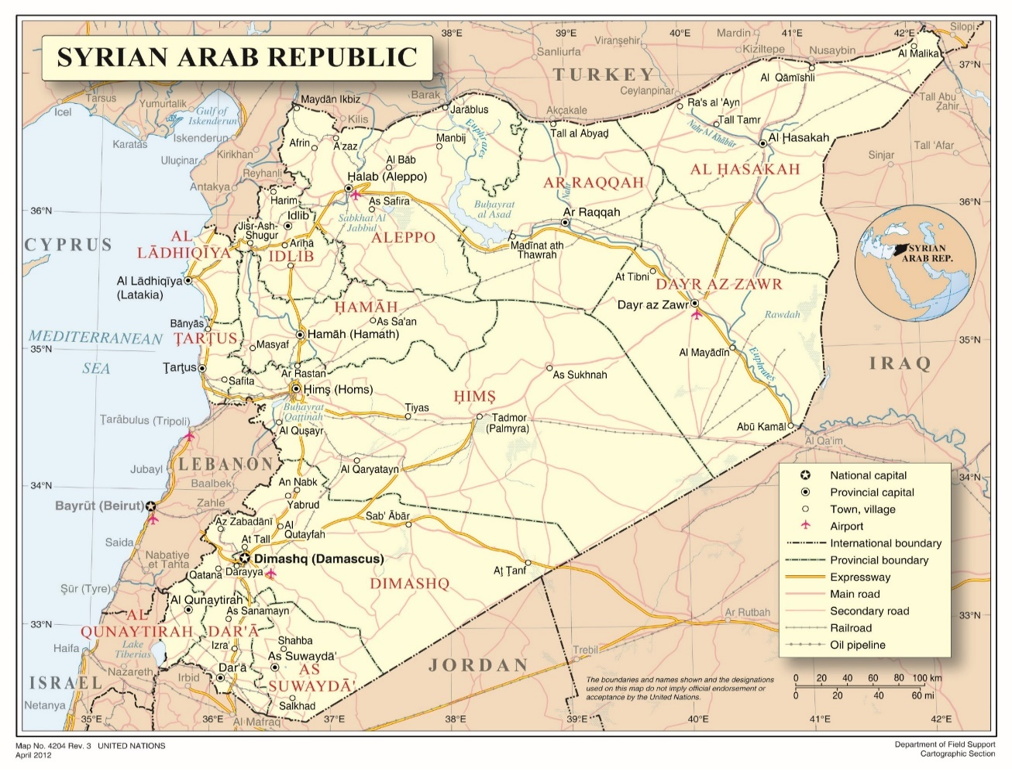
Annex II - Overview of main detention facilities in the Syrian Arab Republic where the Commission has verified violations

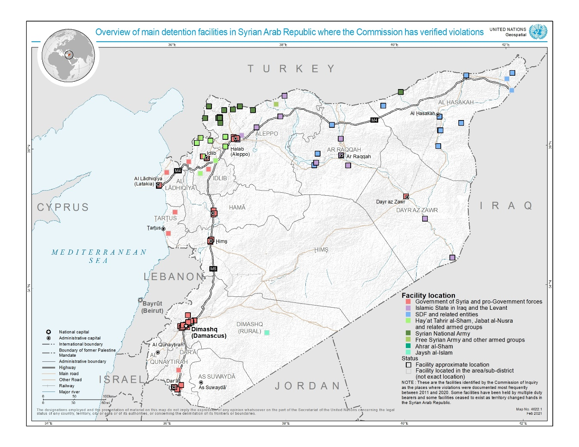
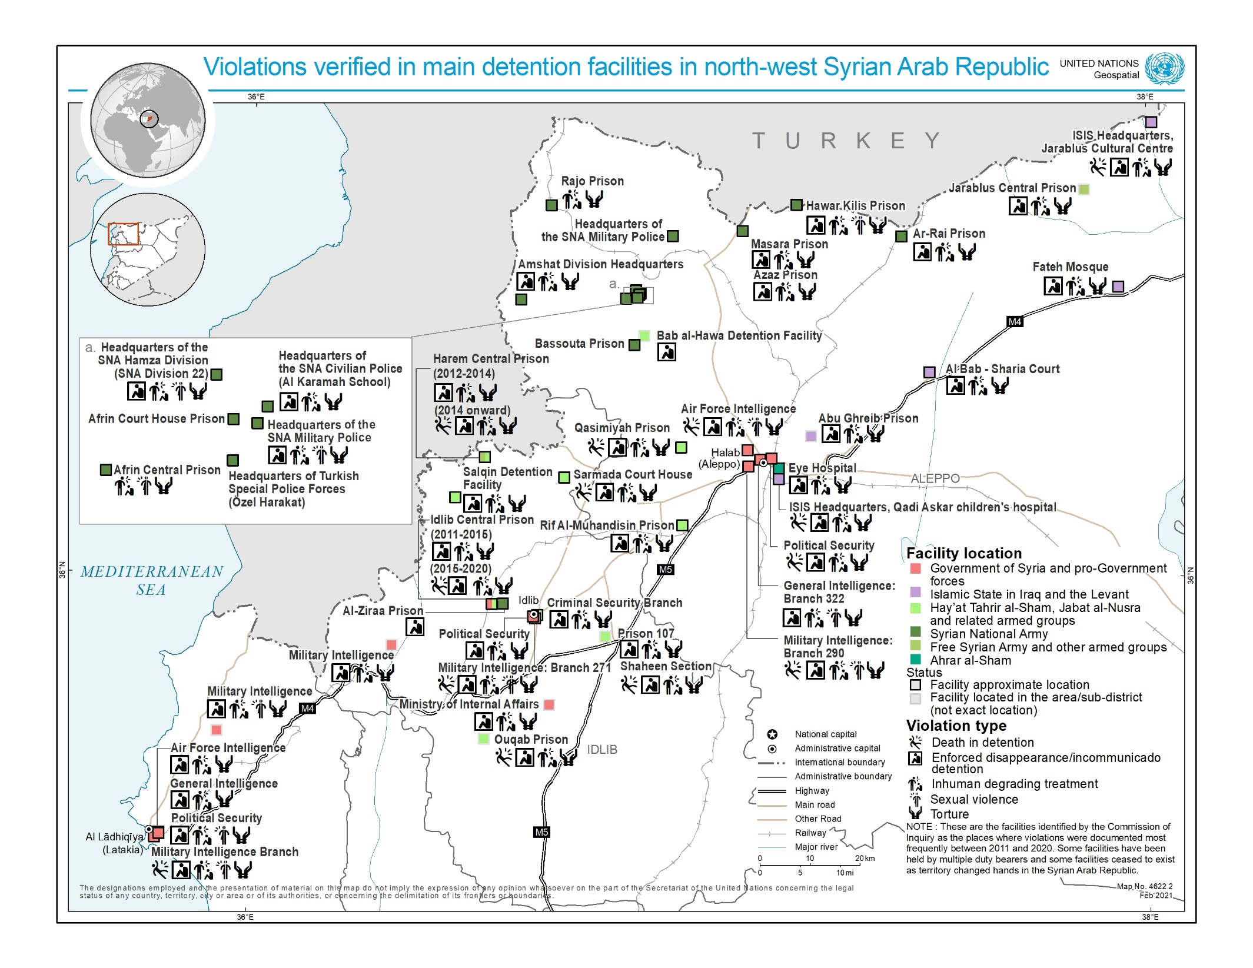
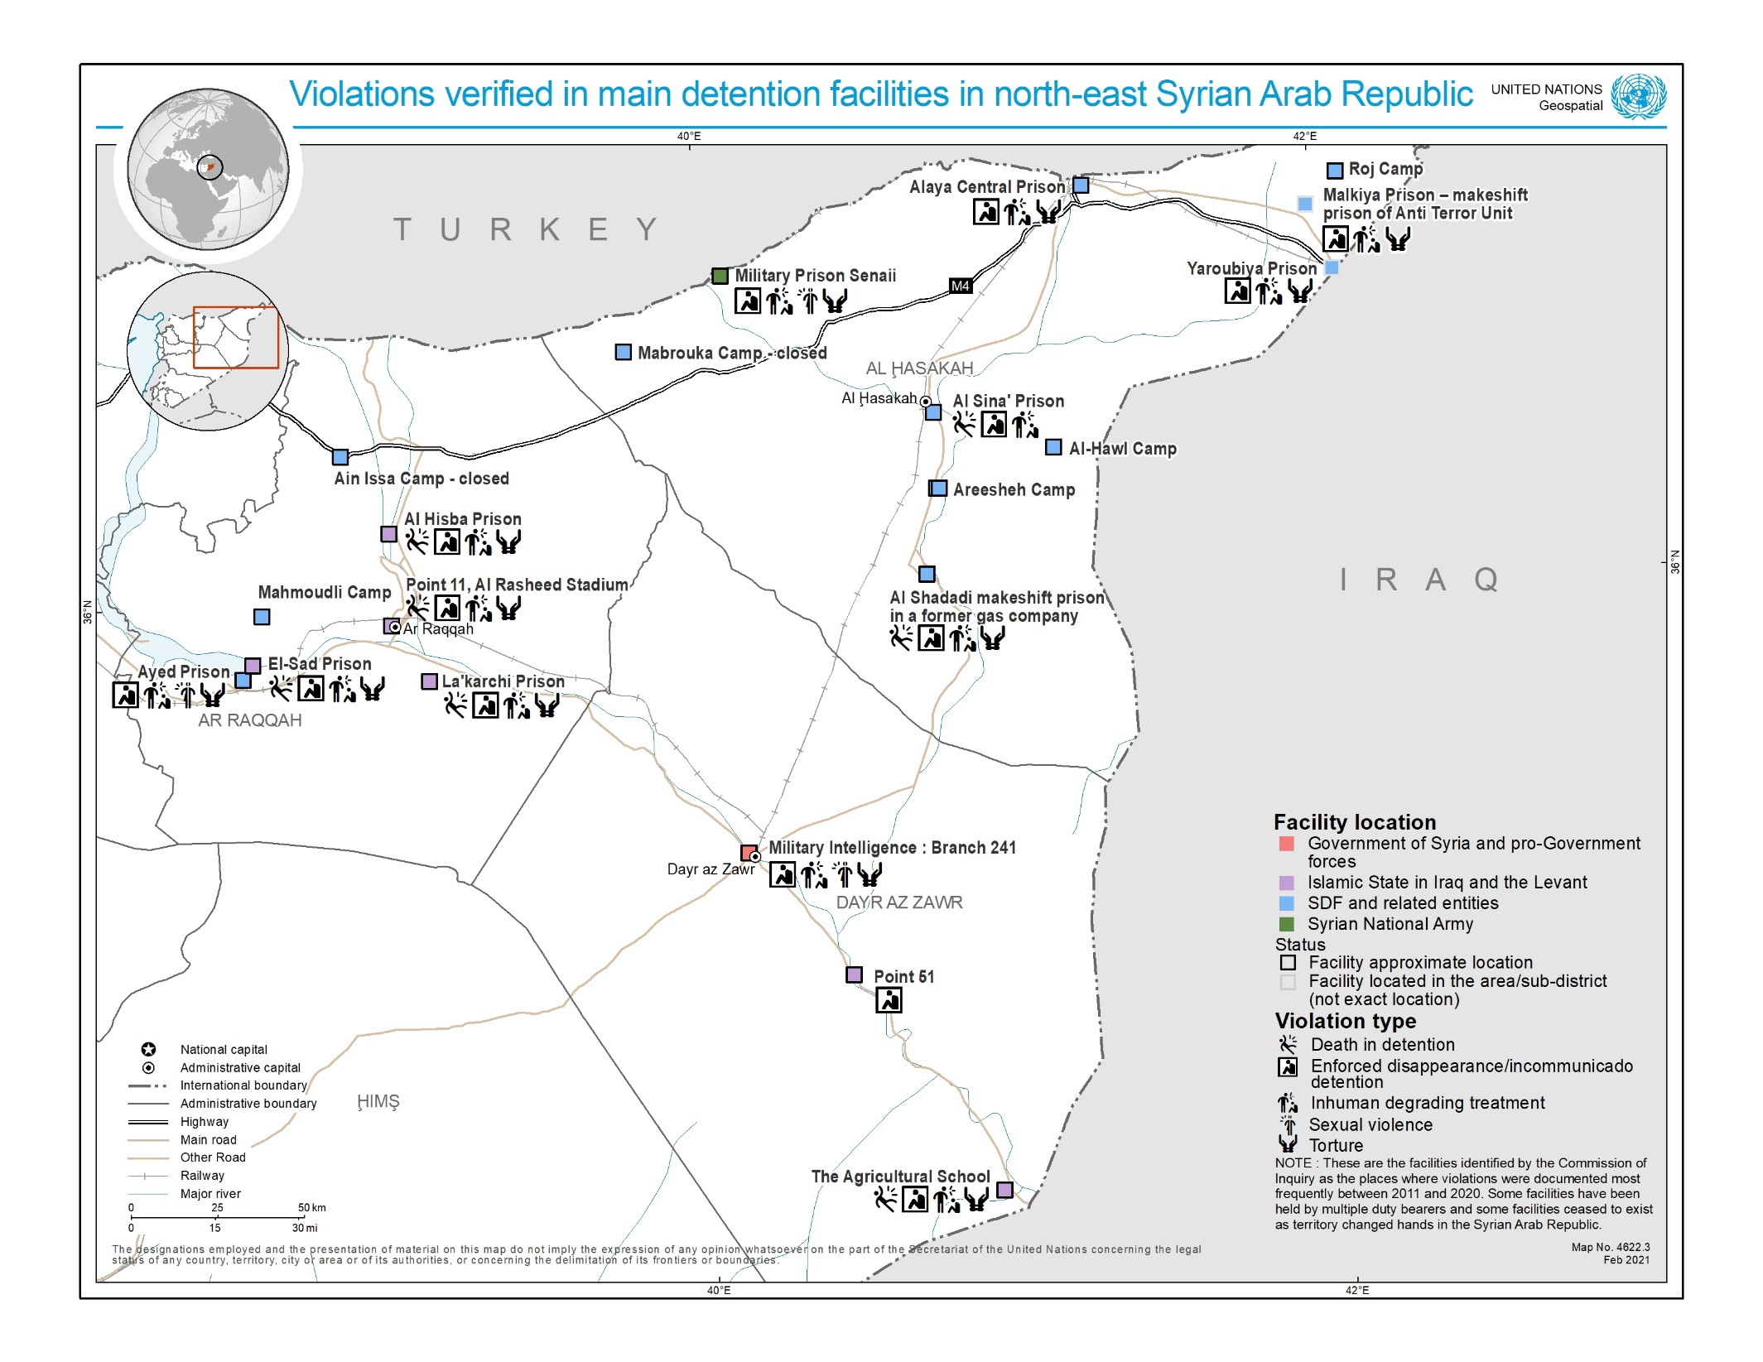
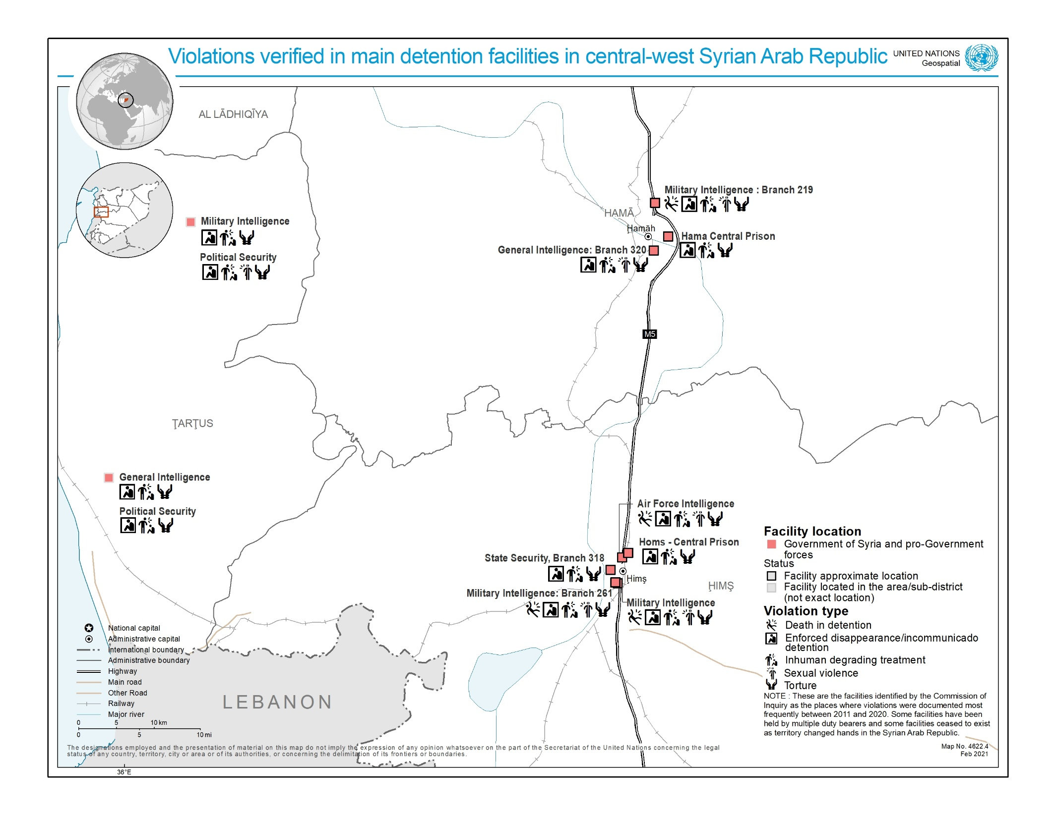
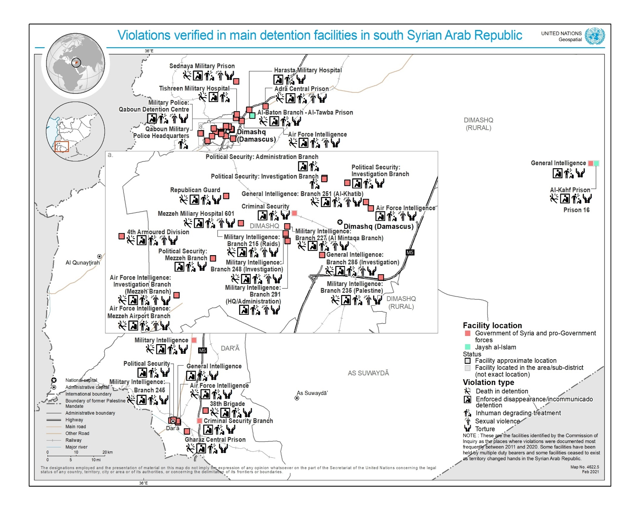
Annex III
Methodology of the data collection
1. Given that this present report covers nearly a decade of detention and related violations in the Syrian Arab Republic, the Commission issued a general call for submissions and sent out specific requests for information to entities having reportedly deprived people of their liberty in Syria since 2011, including United Nations Member States, in order to request data on the prevalence of arbitrary detention, and the related violations covered by this report, in the Syrian Arab Republic. Requests were also sent to other United Nations entities.
2. In view of the mandate to cover nearly a decade of detention in the Syrian Arab Republic, a quantitative analysis of the Commission’s own interviews related to detention was also undertaken, to provide a basic overview of trends over the entirety of the conflict.
3. To this end, the Commission analysed its own database of interviews and information that comprises over 7,874 separate interviews with victims, witnesses and other sources conducted since March 2011.
4. Following a review by Commission staff, the analysis revealed that 2,658 interviews were relevant to the issue of arbitrary detention and related violations committed by nearly all parties in the Syrian Arab Republic. In reviewing its own collection of interviews, staff members of the Commission took note of information related to the violations of enforced disappearance and incommunicado detention, torture, inhuman or degrading treatment and sexual violence through a basic methodology. This methodology was to note if the interviewee has either experienced a violation or had knowledge of an incident that took place, either through witnessing it directly or receiving credible reports of the incident. A third category was used when both apply, i.e. the person being interviewed had personally experienced the violation and, in addition, had either directly witnessed or received credible reports of similar violations suffered by others.
5. This methodology allowed the Commission to create a dataset of those who it has interviewed over nearly 10 years that had directly experienced a violation, as well as another category of those who had first or second hand knowledge of such violations. The methodology for death in detention was more nuanced due to the obstacles surrounding the reporting of this issue. In this regard, the data set was completed by analysing whether information regarding death in detention had been received via reports or through witnesses of the death, through the provision of a death certificate, if the interviewee say the saw body and, lastly, when the interviewee had received the body and a death certificate.
6. It should be noted that the interviews of the Commission were conducted over almost a decade without a view to undertaking such quantitative statistical analysis. Therefore, inferences taken from the data were limited in the following ways. Where an interview covered a specific violation, this has been recorded. However this methodology cannot take into account instances where a person was not asked about a specific violation during a given interview, notwithstanding that some interviewees may have had such additional information. In this regard, where the percentages reported do not add up to 100, the unmentioned quantity relates to an “unknown” category. Worth noting also is that testimonies focussing on severe violations, such as rape or torture, may have been less inclined to also cover comparatively less severe violations related to, for instance, detention conditions. In addition, the sample collected by the Commission was subject to the investigative priorities of the period during it was conducted. Lastly, in terms of caveats, most interviews identified multiple victims and it was not possible to record this information within the restrictions of the data review, therefore the data is limited by just examining one interview as one entry. The information therefore gives an indication of how often an issue was reported during interviewees, but does not attempt to give an indication of the full scale of violations documented by the Commission.
7. Compounding this, the brutal oppression of a vast number of communities living under the control of both the Government and armed groups has led to a palpable fear of reprisals against individuals for speaking out on arbitrary detention and related violations. In recent years, the reduced prospects for Syrians to leave the country, or areas controlled by armed actors, has in turn impaired the Commission’s and other organisations’ ability to interview victims and witnesses and document violations due to protection risks.
8. The statistics are presented to give a broad overview of trends over the entirety of the conflict and are not intended to be a comprehensive analysis of all detention related violations that have taken place in that time. In this regard, the legal and factual findings within this report are based on individual cases noted in the individual duty bearer chapters that have been assessed to meet the Commission’s standard of proof of reasonable grounds to believe.

* The present report was submitted after the deadline in order to reflect the most recent developments.
** ** The annexes to the present report are circulated as received, in the language of submission only.
This report complements the Commission’s recently published report A/HRC/46/54, which provides an overview of the key recurrent human rights concerns and trends over the course of the entire conflict.
A/HRC/S-17/2/Add.1, para. 62.
A/HRC/21/50, annex II, paras. 1–3. With that determination, the Commission applied international humanitarian law, as well as customary international humanitarian law alongside international human rights law.
The Commission continues to regard Islamic State in Iraq and the Levant (ISIL), Hay’at Tahrir al Sham (HTS), Hurras al-Din and other al-Qaida-aligned groups as terrorist entities, as designated by the Security Council pursuant to its resolutions 1267 (1999), 1989 (2011), 2170 (2014) and 2253 (2015).
See A/HRC/46/54. Section II.A and Annex II.
“Pro-government forces” is used when there are multiple allied actors operating and disambiguation to the Commission’s standard of proof is not possible. It can, but does not always, include regular Syrian military, police and intelligence forces, pro-government militia, both foreign and domestic, including the so-called NDF and Shabiha, and elements of foreign allied forces.
The commissioners are Paulo Sérgio Pinheiro (Chair), Karen Koning Abu Zayd and Hanny Megally.
Most interviews were conducted in person. However, owing to the COVID-19 pandemic and the United Nations regular budget liquidity crisis, many interviews in 2020 were conducted virtually and were comparatively fewer.
Issued in October 2020, see www.ohchr.org/coisyria.
Investigations remain curtailed by the denial of access to the country and protection concerns in relation to interviewees. In all cases, “do no harm” remained the guiding principle. The Commission would like to thank all who provided information, in particular the thousands of victims and witnesses, as well as States, UN entities and non-Governmental organizations who responded to the call for submissions and information requests.
Many testimonies covered detention-related violations by multiple duty bearers. However, only one duty bearer responsible for the most significant violations for the interviewee was reflected in the overall dataset.
While current estimates differ, UN sources have approximated that 74 per cent of Syrians are Sunni Muslim; 16 per cent are other Muslim sects (Shia, Alawite, Druze, Kurdish); while Christians make up 10 per cent of the population and small Jewish communities reside in Damascus, al-Qamishli, and Aleppo.
The designations employed and the presentation of material on this map do not imply the expression of any opinion whatsoever on the part of the Secretariat of the United Nations concerning the legal status of any country, territory, city or area or of its authorities, or concerning the delimitation of its frontiers or boundaries.
A/HRC/24/46 para. 57, A/HRC/31/CRP.1 para. 88.
A/HRC/38/CRP.3 section IX.B.
Challenges to documenting sexual and gender-based violations include social and cultural stigma. This greatly reduces the willingness of survivors to disclose sexual violence they endured.
These include the military and civil police forces and four intelligence agencies: the Military Intelligence Directorate, the Air Force Intelligence Directorate, the General Intelligence Directorate, and the Political Security Directorate.
Each node corresponds to either the victim’s origin (in blue) or the detention facility location (in red). The width of the lines between victim origins and detention locations corresponds to the number of victims moved. The boundaries and names shown and the designations used on this map do not imply official endorsement or acceptance by the United Nations.
A/HRC/24/46, para. 49, 89-93.
A/HRC/31/CRP.1, para. 65.
A “regularly constituted court” means a court that affords essential judicial guarantees including those of independence and impartiality. See “Elements of crimes” published by the International Criminal Court, 2011, ISBN No. 92-9227-232-2.
A/HRC/24/46, para 47-48.
A/HRC/34/CRP.3.
https://www.youtube.com/watch?v=-4bxlxUcQ14&feature=youtu.be.
A/HRC/39/65 and A/HRC/43/57.
A/HRC/46/54.
A/HRC/45/31 para 46.
http://www.mfa.gov.tr/relations-between-turkey%E2%80%93syria.en.mfa.
A/HRC/39/65, para. 25.
A/HRC/43/57, paras. 39–40. A/HRC/45/31, para. 46 and 52-56.
A/HRC/45/31, para. 46 and 52-58. A/HRC/43/57, para. 39-41.
A/HRC/45/31 para 12.
A/HRC/45/31, para. 50.
A/HRC/43/57, para. 57.
A/HRC/45/31, paras. 59-62.
SDF were formed as an alliance primarily comprising forces of the Kurdish People’s Protection Units and their allies among Arab, Assyrian and other opposition armed groups.
A/HRC/40/70, para. 10.
Some detainees and internees held by the SDF on suspicions of affiliation to ISIL described being interrogated also by officials of Member States allied against ISIL, including of the United States.
A/HRC/46/54, para. 17.
A/HRC/45/31 para 77.
A/HRC/45/31, para. 75.
A/HRC/45/31 para 78.
Both Ain Issa and Mabrouka camps closed down in the aftermath of Operation Peace Spring in October 2019. While some encamped women escaped, others were transferred to Abu Khasab and Mahmouldi camps in Raqqah governorate, and yet others were reportedly apprehended by armed groups.
A/HRC/45/31, para 74.
See e.g. A/HRC/37/72 Annex III.
A/HRC/43/57, para. 61; A/HRC/45/31, para. 72.
A/HRC/42/51, para 83-5.
https://reliefweb.int/sites/reliefweb.int/files/resources/Repatriation%20of%20foreign%20children %20in%20Syria%20slowed%20by%20COVID-19%20as%20new%20footage%20emerges%20of%20life%20in%20camps.pdf.
A/HRC/28/69, 31-32; A/HRC/46/54, Annex II.
Including the Ansar al-Din Front, Jaysh al-Sunna, Liwa al-Haqq, and the Nour al-Din al-Zenki Movement.
A/HRC/37/72, para 28. A/HRC/39/65, para 52.
A/HRC/44/61, para 5; A/HRC/39/65, para 60 and Salvation Government Ministry of Justice statement, September 2018, available at https://ebaa.news/press-interview/2018/09/13549/.
A/HRC/28/69, para 22; A/HRC/27/60, para 61; A/HRC/30/48, para 129; 37/72/CRP.3, para 57.
A/HRC/31/68, para. 105; A/HRC/34/CRP.3, para. 70.
A/HRC/36/55, para. 41.
A/HRC/40/70 para. 54-57.
A/HRC/44/61
A-HRC-37-CRP-3, para 69.
A-HRC-37-CRP-3, para 67.
A/HRC/44/61, para. 103-104. Also, A/HRC/37/72/CRP.3, ft. 6.
A/HRC/44/61, 93.
A/HRC/30/48, para 97 and A/HRC/28/69, para 104.
A/HRC/44/6, para 94.
A/HRC/27/CRP.3, para. 5-18.
A/HRC/37/CRP.3, para. 72.
A/HRC/31/CRP.1 para. 75.
For maps indicating the relevant geographic areas, see A/HRC/46/54 Annex II.
E.g. A/HRC/25/65, para 46 and A/HRC/40/70 para 43.
A/HRC/32/CRP.2, para. 125, ft. 38 and 11.
A/HRC/32/CRP.2, para 122
A/HRC/27/CRP.3, para 20.
A/HRC/27/CRP.3, para 38.
See A/HRC/43/49, para. 19.
A/HRC/45/31 para 32.
Human Rights Committee, General Comment no. 36, CCPR/C/GC/36, para 58 (2018).
E.g. A/HRC/31/CRP.1.
A/HRC/27/CRP.3 and A/HRC/32/CPR.2.
See generally, A/HRC/32/CRP.2.
A/HRC/40/70, para 57.
Common art. 3 of the Geneva Conventions, See also ICRC Study on Customary International Humanitarian Law (ICRC rule), rules 87, 89, 90, 93, 99, 100 and 156.
This included sentencing alleged suspects without affording them essential judicial guarantees.
A/HRC/31/CRP.1, paras. 101-102.
Including when operating under its former aliases or iterations.
Common art. 3 of the Geneva Conventions, See also ICRC rules 87, 90 and 156.
Ibid, and ICRC rules 89, 96, 100, and 156.
Ibid, and ICRC rules 93 and 156.
Ibid, and ICRC rules 93, 94, and 156.
ICRC rule 98. Enforced disappearances are also characterized as composite war crime by the ICRC, see Rule 156. See also, Report of the Working Group on Enforced or Involuntary Disappearances, A/HRC/45/13, paras. 23-34 and 45 (7 August 2020).
A/HRC/34/CRP.3, para. 103.
The Commission continues to investigate the precise extent to which various SNA brigades and Turkish forces have formed a joint command and control hierarchy.
A/HRC/45/31, para 67-68; A/HRC/34/CRP.3, para. 103. Legal Consequences of the Construction of a Wall in the Occupied Palestinian Territory, Advisory Opinion, I.C.J. Reports 2004, paras. 107–113.
Fourth Geneva Convention (1949), articles 49, 146 and 147, ICRC rule 129.
A/HRC/40/70, para. 10.
A/HRC/37/72, para. 59.
For analysis on internment A/HRC/37/72, Annex II B.
A/HRC/40/70, para. 92.
Basic Principles and Guidelines on the Right to a Remedy and Reparation for Victims of Gross Violations of International Human Rights Law and Serious Violations of International Humanitarian Law, UNGA Resolution 60/147, 16 Dec. 2005. A/HRC/21/50, paras. 21-24. Human Rights Committee, General Comment no. 31, CCPR/C/GC/31, paras 17-20 (2004).
A/HRC/45/31, para. 46 and A/HRC/46/54, section III.B.
A/HRC/46/54 section III.
https://www.government.nl/latest/news/2020/09/18/the-netherlands-holds-syria-responsible-for-gross-human-rights-violations.
Human Rights Committee, General Comment no. 36, CCPR/C/GC/36, para 58 (2018).
A/75/384.
The boundaries and names shown and the designations used on this map do not imply official endorsement or acceptance by the United Nations.
This overview does not exhaustively list facilities in which the Commission has verified violations. It represents a small sample of the facilities at which recurrent violations by duty bearers were documented since 2011. The true number of detention facilities where violations have taken place is far higher than indicated here.
First-hand witness reports and credible second-hand witness reports were counted in the same dataset, to facilitate methodological consistency during data entry, also for cases that could otherwise reasonably be interpreted to fall into either category (such as interviews with health workers seeing and documenting fresh injuries caused by torture first-hand, but without having been present in the cell where the victim was tortured).

